**Packet F: Radiation**

**Materials for Activities used as a Simulation done by Students**

Introduction:

This packet addresses the following misconception, identified as both prevalent and persistent among undergraduate engineering students:

*Students are often confused about the effect of surface properties on the rate of radiative heat transfer.*

This packet includes:

1. Faculty instruction sheet (p. 2) for using the simulation as a class demonstration. **These simulation activities should be run by the students and not the faculty member.**
2. Student assignment sheets (p. 3-6) on the inquiry-based activities that address the targeted misconception. These handouts may either be used for in-class discussions or, more likely, as homework assignments. For the “analysis questions” at the end of each student handout, students should be allowed to discuss answers with small groups of other students in class. Again, these questions should be answered on the provided web-form but may either be answered as homework or in class if appropriate computers / online access is available for each student.
3. Detailed description of the technical analysis for each activity. This is provided in Appendix A and is intended for faculty only (not students).
4. Please record the amount of time using this packet took for you as an instructor. Note both preparation time for the class and actual class time as separate components, please use the questions in Appendix B as a guide for the information we are collecting. Then go to the “Appendix B” online survey to submit your answers.

**Inquiry-Based Activity: Radiation to/from Steam Pipes**

**Simulation used by Students in a Laboratory**

**Faculty Instruction Sheet**

*Introduction:*

This activity demonstrates the effect of color and other surface properties on the rate of radiative heat transfer. The activity uses a computer simulation of the rate at which saturated steam condenses in a pipe surrounded by air at room temperature. The rate at which steam condenses is directly proportional to the net heat loss from the hot steam pipe to the surrounding room, so that the condensation rate is a good measure of the net rate of heat transfer from the pipe.

*Directions for Faculty:*

1. This activity is a simulation. Students will need a device with web access that can run Javascript. To access the simulation, go to <http://www.facstaff.bucknell.edu/mvigeant/HT_JS/Radiation_Pipe/radiation.html>
2. Introduce the problem. Clarify that you want to explore what will happen when the color and other surface properties of a pipe changes and that you want students to think about the effect of these properties on radiative heat transfer. You may want to draw a diagram on the board to clarify the situation or show the simulation screen to make sure students can picture in their heads the scenario in question.
3. Ask students to go through the activity sheets provided on the following pages. This will have them:
   1. Make a series of predictions
   2. Check their predictions by running the appropriate conditions in the simulation.
   3. Let the students perform the experiment then ask the students to answer the analysis questions on the web form provided to you for this activity. Students should be allowed to discuss answers with small groups of other students in class. Again, these questions should be answered on the provided web-form but may either be answered as homework or in class if appropriate computers / online access is available for each student.
4. Please record the amount of time using this packet took for you as an instructor. Note both preparation time for the class and actual class time as separate components, please use the questions in Appendix B as a guide for the information we are collecting. Then go to the “Appendix B” online survey to submit your answers.

**Inquiry-Based Activity 3: Radiation to/from Steam Pipes**

**Student Assignment Sheet**

*Directions for Students*

Please answer each of the questions below after the instructor has described the problem being considered. The initial predictions should be completed in class before you run the simulation, while the analysis may be conducted outside of class or laboratory for homework (ask your instructor), using the web form provided by your instructor. While you should submit individual solutions, you are strongly encouraged to arrive at answers through discussion with laboratory partners or classmates. Remember to put your name or identifying student number on each page of your response and record the amount of time spent completing this packet on question 5 of the analysis section.

*Materials:*

You need a web-enabled device that can run Javascript.

Parameter values used in the simulation were taken from: <http://www.electro-optical.com/bb_rad/emissivity/matlemisivty.htm>

*Directions:*

The Effect of Surface Color:

You will be asked to predict the effect of color and other surface properties on the rate of radiative heat transfer. This activity uses a computer simulation of the rate at which saturated steam condenses in a pipe surrounded by air at room temperature. The rate at which steam condenses is directly proportional to the net heat loss from the hot steam pipe to the surrounding room, so that the condensation rate is a good measure of the net rate of heat transfer from the pipe.

Please predict the relative rates of heat transfer from otherwise identical pipes which are (1) painted black (2) painted white (3) unpainted, polished copper

1. Before doing anything with the simulation, **individually** **predict** the *order* in which the pipes will fill with condensate. Rank the 3 pipes (black paint, white paint, polished copper) in order of which will fill fastest and explain your reasoning in the space provided.

1. In addition to ranking the pipes, **individually predict** *how much* you think the rates of heat transfer will differ between each pipe. For example, do you think that one pipe will be twice as fast as the second fastest which will be about 10% faster than the slowest pipe, etc.? Again, explain your reasoning.

*Directions:* This activity is a simulation. To access the simulation, go to <http://www.facstaff.bucknell.edu/mvigeant/HT_JS/Radiation_Pipe/radiation.html> Run the simulation at the initial conditions Steam Temp = 100ºC, Room Temp = 20ºC and Heat Transfer Coefficient = 1 W/m2*K (if applicable) pipe surfaces black and white to examine the effect of surface properties on heat transfer rates. Record the time it takes each pipe to fill with condensate and consequently which pipe has the highest heat transfer rate in each of the following scenarios. Recall that the pipe with the shortest fill time has the fastest heat transfer rate.

1. Compare the fill time in the black vs. white pipe. Which situation produced the faster rate of heat transfer and how significant was the difference in rates?
2. Were your predictions correct about the order and relative magnitude of any difference between black and white painted pipes? If not, how did your observations differ from your predictions?
3. If your predictions of the effect of paint color in question 3 or question 4 differed from what the simulation showed, come up with another explanation for the simulation results and explain why your initial predictions were in error. You may talk to other students in arriving at your explanation.

*Directions:*  Please run the simulation again at the same conditions, only now comparing the white and polished copper pipes.

1. Compare the fill time in the copper vs. white pipe. Which situation produced the faster rate of heat transfer and how significant was the difference in rates?
2. Were your predictions correct about the order and relative magnitude of any difference? If not, how did your observations differ from your predictions?
3. If your predictions of the effect of surface properties in question 6 or question 7 differed from what the simulation showed, come up with another explanation for the simulation results and explain why your initial predictions were in error. You may talk to other students in arriving at your explanation.

The Effect of the other System Parameters

The simulation is set up to allow you to examine the effect of other system parameters such as steam temperature and heat transfer coefficient on the relative rates of heat transfer (if you do not see the option to modify the heat transfer coefficient, ask your instructor for the link to that version of the simulation; if unavailable, skip that part of question 10).

1. Before playing with the simulation, please predict whether anyset of conditions will change the *order* in which each pipe fills with condensate? Explain the reason for your prediction
2. Run the simulation comparing different pipes and different conditions of steam temperature and heat transfer coefficients. Observe if any set of conditions change the order of which pipe fills more quickly. Also note which conditions minimize the difference in heat transfer rates between the 3 pipes and whether any set of conditions produces identical fill times. Compare your observations with your predictions in question 9 and explain any discrepancies.

Analysis:

*These upcoming questions* are to be completed online in the provided web form. Your instructor will tell you if this will be done as homework or in-class. These written questions are for your reference.

*You should discuss your answers to all questions with at least 2 other students come to agreement before submitting your responses.*

1. The simulation results obviously flow from the mathematical model for this system. Write the mathematical equations for the rate of heat transfer from the surface of each pipe, using your knowledge of the appropriate heat transfer mechanisms and equations for those mechanisms.
2. Looking at your answer to question 1, where do the surface properties enter your model? With this information, please use your model to explain the relative rates that each of the 3 pipes fills with condensate.
3. Please list each of the situations where your initial predictions about the rate of heat transfer from the different pipes were not matched by reality. For each of those cases, summarize how your predictions differed from what really happened and explain what you missed that led to the failed prediction. Was there a common misconception that led to any of these failed predictions?
4. What, if anything, did you learn from these activities about how color and other surface properties affect the rate of surface radiation from an object?
5. Please indicate the amount of time you spent completing this packet of questions.

**Inquiry-Based Activity 4: Thermal Radiation from Heat Lamps**

*Introduction:*

This activity examines the effect of color and other surface properties on the heating and cooling of objects. Specifically, you will examine the heating and cooling rates of surfaces which are (1) painted black (2) painted white and (3) polished copper using a simulation. The simulation models the scenario shown in the photos below. Picture 3 temperature probes (thermocouples) attached to 3 copper tubes.

One copper tube is painted black, one painted white, while the other is left natural copper but is highly polished. These probes are placed under a strong heat lamp. The heat lamp is then turned on.

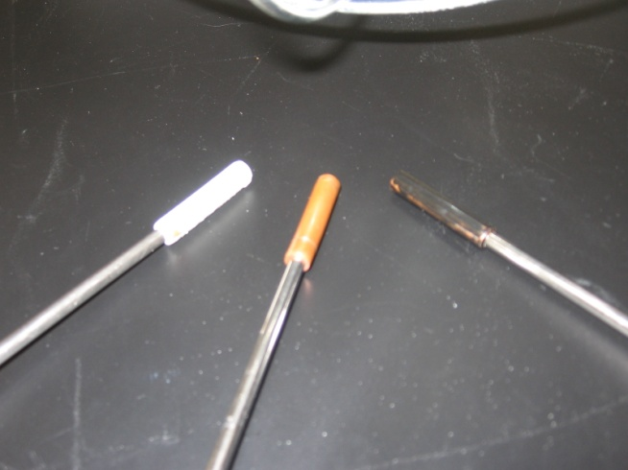 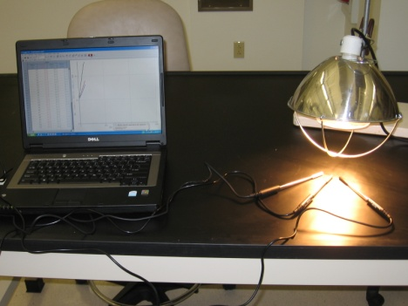

*Directions:*

1. Rank in order which probes you think will heat fastest when exposed to a strong heat lamp. Record your prediction and reason why below:
2. Now imagine each of these 3 copper tubes all at 100C exposed to room temperature air, which will cause them to cool. Rank *in order* which probes you think will cool most quickly when removed from boiling water? Record your prediction below.
3. You need a web enabled device that can run Javascript. See which probes actually heat most quickly when exposed to a heat lamp by running the simulation at <http://www.facstaff.bucknell.edu/mvigeant/HT_JS/Light_Radiation/lightRadiation.html>
4. Record the order in which the tubes heat most quickly below; run the simulation several times at different lamp intensities. Does the result change?:
5. Now see which probes cool the most quickly by running the cooling simulation at <http://www.facstaff.bucknell.edu/mvigeant/HT_JS/Light_Radiation/lightRadiation.html> Compare cooling rates when all of the tubes start at a temperature of at least 100C. Note the order in which they cool in the space below. Run the simulation several times at different start temperatures. Does the result change?

*Analysis:*

*These upcoming questions* are to be completed online in the provided web form. Your instructor will tell you if this will be done as homework or in-class. These written questions are for your reference.

1. Compare your initial predictions in questions 1 and 2 to what actually happened.
2. If the simulation results do not match your initial predictions, come up with a new explanation of the results. In your explanations, you should pay particular attention to *why* your original predictions were not correct and how you had to revise your thinking to explain what happened.

*You should discuss your answers with at least 2 other students and agree on what happened and why.*

1. Write the mathematical equations which describe both the rate of heating and cooling during the separate phases of this experiment. You may use a textbook or other references if necessary.
2. Looking at your model, what parameters in your equations depend on the surface properties, and how do these parameter values in your model explain the observed behavior? You may look up any needed parameter values, but note that properties such as absorptivity can be strong functions of wave length or the temperature of the radiation source, so choose property values with this in mind. One source of values can be found at <http://www.solarmirror.com/fom/fom-serve/cache/43.html>, and heat transfer textbooks are also excellent sources of relevant physical property data.
3. What, if anything, did you learn in this activity?
4. Please indicate the amount of time you spent completing this packet of questions.

**Appendix A.** **Technical Analysis for Inquiry-Based Activity 3: Radiation to/from Steam Pipes**

Inquiry-Based Activity 3: Radiation to/from Steam Pipes

This is a simulation of an actual physical experiment which is run at Bucknell and which verifies the trends seen in the simulation. Students should note the following trends in the simulation, many of which are counterintuitive for them. First, both the white and black painted surface collect condensate much more quickly than the polished copper pipe. This is because painted surfaces have fairly high (0.9-0.98) emissivity and absorptivity values for radiation of the relevant wavelengths here [1]. The emissivity and absorptivity of a polished metal surface is much smaller. Since the temperature of the pipe is much higher than the surroundings, emission of radiation is the dominant mechanism distinguishing the rates of condensate collection, so the surface with the higher emissivity has the fastest condensate collection rate.

The emissivity of black paint is slightly higher than that for white paint in many cases, which explains the slight different in the model predictions. Many students think that black “holds on” to heat better because black objects heat up faster in the sun, but it’s the emissivity and absorptivity values which matter, and emissivity which dominates for cooling objects.

[1] Note that the absorptivity of white paint for radiation for much smaller wavelengths from hot objects such as the sun will vary considerably from the values relevant for this experiment.

**Analysis: Heat Lamp Simulation**

Laboratory Set-Up

The simulation models the experiment shown below, which is set up with three thermocouples sheathed by three different ¼” copper tubes. Tube size may vary depending on the size of the thermocouples used (good contact with the inside of the tube is necessary). One copper tube is painted black, one painted white, while the other is left natural copper. For cooling, the experiment heated the probes to a constant temperature of 100C in a water bath, the probes were quickly dried and then allowed to cool.

 

Technical analysis:

*Why does the black metal tube heat up faster?*

The absorptivity value for black paint is much higher than the white paint, which is higher than that for the polished copper tubing. Students are likely to predict that black surfaces heat up faster, but they may juxtapose the order of the white and polished surfaces, thinking that white reflects all radiation and will therefore heat up the most slowly. In general, the white painted surface will heat more quickly than the polished copper (especially if the copper is highly polished) because it has a higher absorptivity value. However, if the metal surface is not highly polished, the two values may be similar, and consequently, so will be the heating rates.

*Why do the black and white metal tubes cool down fastest?*

It is often thought that since the black painted tube heats up faster, it will also “hold heat” more effectively and therefore cool down the slowest, which of course is not true. The rate of radiative cooling depends on the emissivity and painted surfaces, independent of color, generally have emissivity values of 0.9-0.98. The emissivity of the polished copper (depending on how highly polished it is) is about 0.02-0.2. The values explain why the painted surfaces cool most quickly. Depending on the paint you use, you may find small differences between the cooling rates of the white and black paint, but because these values are close and vary depending on the type of paint, it is impossible to predict in advance how your painted surfaces will react, other than to predict that the polished copper will cool more slowly under conditions where radiation is significant relevant to other cooling mechanisms such as convection.

**Appendix B. (For Faculty Only) Evaluations**

*Directions:* Please fill out the form below for evaluation purposes.

Institution:

Name of Instructor:

Date:

Class:

Activity Name:

Number of Students:

|  |  |
| --- | --- |
| How much time did you spend on class preparation for the activity? |  |
| How much class time did you spend on the activity? |  |
| Which questions were answered in class? Outside class? |  |
| On average, how much time did the students spend on answering the questions in class? |  |
| On average, how much time did the students spend on the questions assigned for homework? |  |
| Other Comments/Suggestions for improvement |  |